Disapproval Interjections

🔹 What Are Disapproval Interjections?
# Source: AI Source: Provided by: [Data Path: Persons Table -> ID Column: 1, Name_En Column: Motasem Essam] -> From: [Chatgpt (GPT-4-turbo)] on [7/28/2025]
Disapproval interjections are short expressions used to show criticism, rejection, dislike, or disagreement with something.
They communicate a negative emotional response to actions, ideas, or events.

✅ Key Features
# Source: AI Source: Provided by: [Data Path: Persons Table -> ID Column: 1, Name_En Column: Motasem Essam] -> From: [Chatgpt (GPT-4-turbo)] on [7/28/2025]
- Express reproach, dislike, disagreement, or disgust
- Common in spoken conversations and emotional reactions
- Often followed by an exclamation mark (!) or pause (,)

🧩 Common Disapproval Interjections
# Source: AI Source: Provided by: [Data Path: Persons Table -> ID Column: 1, Name_En Column: Motasem Essam] -> From: [Chatgpt (GPT-4-turbo)] on [7/28/2025]
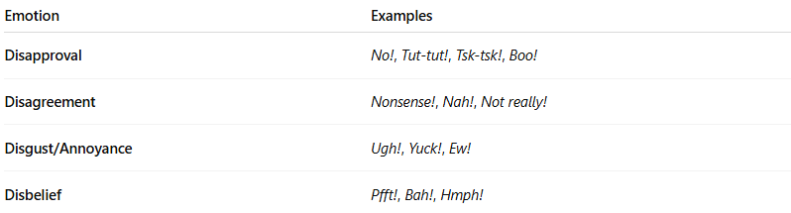
Emotion | Examples
Disapproval | No!, Tut-tut!, Tsk-tsk!, Boo!
Disagreement | Nonsense!, Nah!, Not really!
Disgust/Annoyance | Ugh!, Yuck!, Ew!
Disbelief | Pfft!, Bah!, Hmph!

📚 Example Sentences
# Source: AI Source: Provided by: [Data Path: Persons Table -> ID Column: 1, Name_En Column: Motasem Essam] -> From: [Chatgpt (GPT-4-turbo)] on [7/28/2025]
- No! That’s not acceptable. (strong disapproval)
- Tsk-tsk! You shouldn’t have done that. (mild criticism)
- Ugh! I can’t believe this mess. (disgust/annoyance)
- Boo! That was a terrible performance. (disapproval)
- Nah! I don’t think that’s true. (casual disagreement)

